

1. Report EUR xxxxx EN

SUMO v1.3.3

1 New Functionalities 3

1.1 Analysis with Ice shapefile 3

1.2 Using Ice shape file with Multiple Analysis in batch Mode 3

1.2.1 Configuration Files parameter 3

1.2.2 Using Ice Shape file in Interactive mode 4

1.2.2.1 Import vector 4

1.2.2.2 Vds analysis 5

2 Problems and Improvements 5

3 Multithreading batch mode 5

4 Batchmode with File list 6

# New Functionalities

This new Sumo version includes this new main functionalities:

* Analysis with Ice shapefile (First version) for interactive and batch mode : it is possible to use a shape file to exclude ice from the VDS analysis to avoid to much false alarm.
* Multithreading batch mode : the batch mode now can run in multithreading to optimize the performance
* Batchmode with a file list : possibility to specify a list of images to analyze using a text file

## Analysis with Ice shapefile

In this version Sumo can analyze images using a shape file to exclude ice from the analysis.  
 Using the interactive mode,   
 Shapefile for Ice could be downloaded from the NOA service or importing a local file.

## Using Ice shape file with Multiple Analysis in batch Mode

The multiple batch mode analysis use a file configuration as explained in a previous document.  
 To use ice shape files in a batch mode analysis new parameters was added in the configuration file to specify the repository and to search the correct shape file for the analysis.When we use a remote repository, the ice shape file is downloaded before to analyze the single images.

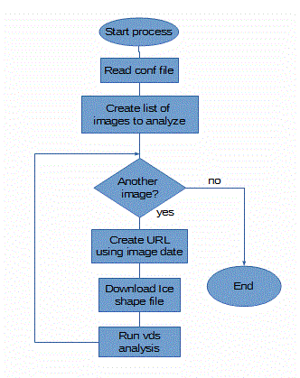

### Configuration Files parameter

* ***Param: use_ice m****andatory*Main param to use or not the ice shape file in the analysis and to specify if you want to use a local or remote repository or a single shape file.   
    
  Possible values:  
  **none:** analisys without ice  
  **single:** use only one shp file for all images  
  **repository:** use a remote or local repository to find the correct ice shp file searching for date
* ***Param: ice_repository_site*** *optional*Possible values:  
  **local:** to use a local repository
* ***Param: ice_repository_path*** *optional*This param is an url “pattern” for a remote or local repository : it is an URL that could contains a java date pattern between “%”. If a pattern is used it will be replaced with the correct date.  
  Example : http://www.natice.noaa.gov/pub/daily/arctic/%yyyy%/ice_edge/  
  Instead, it is an absolute path for a single shape file.
* ***Param: ice_pattern_name*** *optional*  
  The name of the file tha could contain a java date pattern. The pattern will be replaced with the image date to analyze and identify the correct shape file .

#noaa

#%yyyyDDD% java date format yyyy=year DDD=day of year

#local remote

ice_repository_site=remote

ice_repository_path=http://www.natice.noaa.gov/pub/daily/arctic/%yyyy%/ice_edge/

ice_pattern_name=nic_autoc%yyyyDDD%n_pl_a.zip

Example:

#Default is none

#none=analysis without ice

#single=use only one shp file for all images

#repository=use a remote or local repository to find the correct ice shp file searching for date

use_ice=repository

#noaa

#%yyyyDDD% java date format yyyy=year DDD=day of year

#local remote

ice_repository_site=remote

ice_repository_path=http://www.natice.noaa.gov/pub/daily/arctic/%yyyy%/ice_edge/

ice_pattern_name=nic_autoc%yyyyDDD%n_pl_a.zip

### Using Ice Shape file in Interactive mode

To integrate the use of the Ice shape file in the interactive mode the “Import Vector” and the “VDS Analysis” functions are changed.

#### Import vector

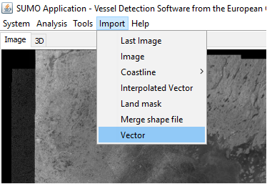

Now when we choose the “import vector” function we need to specify:

* The “Mask type” of the vector as showed below. The “Mask type” is used to specify if the shape file is for : coastline, ice or other. Only the shape file loaded as Ice are or coastline will be available for the VDS analysis.
* If the shape file is local or remote. In this moment, NOA is the only remote repository avalaible.   
  The NOA repository contains one shp file for each day , and the name of the shape file contains the date of the day. The URL to download the correct shape file for the analysis is builded using the image date.  
  If you don't check “local from remote..” a file explorer dialog will be opened to choose a local shape file.

|  |  |
| --- | --- |
|  | Type: “shp”   Mask type: “ice”  “Load from remote site” : checked to download automatically the shape file from NOA. If you don't check this a file explorer dialog will be opened to choose a local shape file. |

#### Vds analysis

For the vds analysis now we have a new parameter in the “Vds Dialog” to select the ice parameter.

If you have loaded an Ice shape file you can select it for the VDS Analysis . If you do this all pixels   
“in the shape file” will be excluded from the analysis like the coastline.

# Problems and Improvements

In this first release for the ice, pixel identified as Ice are excluded from the analysis like as for the coastline. So in this moment pixel are used or not for the analysis.

Problem:

* Using shape file for coastline and ice in some images, exclude almost or the complete image from the analysis
* Possible targets near the ice, closed in the shape file, will be excluded from the analysis.

Improvement: In the next Sumo version , ice pixels will be classified as ice, and the area in the shape are not excluded from the analysis. New threshold values will be calculated for the ice pixels in order to detect targets also in the ice.

## Multithreading batch mode

In this version the batch mode is implemented using the java.util.concurrent.ExecutorService.  
 The java.util.concurrent.ExecutorService interface represents an asynchronous execution mechanism which is capable of executing tasks in the background.

## Batchmode with File list

With this function we can specify the list of the images to analyze in a txt file . Each row in the txt file is an absolute path to an image to analyze.  
 To do this, you have to use this parameters:

use_file_list=true to use the txt file  
 input_file= absolute path to txt file

Example of list file :

H:/sat/S1A_EW_GRDM_1SDH_20160312T221037_20160312T221137_010342_00F516_BB3A.SAFE

H:/sat/S1A_IW_GRDH_1SDH_20140607T205125_20140607T205150_000949_000EC8_CDCE.SAFE

H:/sat/S1A_IW_GRDH_1SDV_20141012T180214_20141012T180243_002800_003275_C958.SAFE

H:/sat/S1A_IW_GRDH_1SDV_20150911T181748_20150911T181813_007671_00AA55_1F8E.SAFE

H:/sat/S1A_IW_GRDH_1SDV_20160202T164016_20160202T164041_009770_00E487_3FF2.SAFE

H:/sat/S1A_IW_GRDH_1SDV_20160204T163028_20160204T163053_009799_00E55A_EB9A.SAFE

H:/sat/S1A_IW_GRDH_1SSV_20141006T205930_20141006T205955_002714_00309F_FE9F.SAFE

1. 
2. ISBN xxx-xx-xx-xxxxx-x

LB-NA-xxxxx-EN-N